

The Roots of Investing



**A Guide for the Person who wants to Grow Wealth out of One Seed.**

**Let this Guide be that Seed.**

**By Ricardo Jacome**

Copyright © 2019 by Ricardo Jacome

All rights reserved. No part of this book may be reproduced in any form or by any electronic or mechanical means, including information storage, and retrieval systems, without permission in writing from the publisher. Reviewers may quote brief passages in a review.

Library of Congress Control Number

The prices and rates stated and shown in this book are subject to change.

Graphs on: 13,14, 16-22, and 24,25 and were obtained from Robinhood Markets, Inc. All rights reserved.

Graphs on: 15 were obtained from Yahoo Finance. All rights reserved.

Graphs on: 26 and 30 were provided by the author.

Contents

Preface 9

Overview 11

Chapter 1: Introduction 12

Why use this? 12

How to read this. 12

Why Robinhood? 13

Chapter 2: What is Out There to Invest In? 14

Why do stocks exist? 16

Where are Stock Transactions made? 17

Different Investment Types 17

Chapter 3: Classification of Trends 19

Upwards Trends or “Bullish” Trends 20

Downward Trends or “Bearish” Trends 24

Horizontal Trends 27

Smaller Time Frame Trends 29

What Affects Trends? 34

Chapter 4: Classifications of Stocks 36

Level 1 - Volatile and Constant Stocks 36

Level 2 - Service/Product Stocks 36

Remarks 38

Chapter 5: Stock Trading Strategies 40

How to Predict Trends? 40

Trading Strategies List 40

Chapter 6: The Suggested Stock Trading Strategy 42

Summary of Previous Chapters 42

Long-Term Investments on Stocks 43

Diversification 44

Chapter 7: Quick Example List with Strategies 46

Quick-Example List 46

Chapter 8: Key Summary, Pro-Tips and Suggested Readings 48

Notes to consider: 49

Suggested Readings 49

# Preface

This book is my personal attempt to make a difference in the stigma that exists when it comes to investing in stocks. If you believe that investing is not for you, keep this book. If you think it is hard to understand, read this book. If you want to start building your wealth, start with this book.

Investing is something that every individual should have some degree of knowledge. Regardless of your profession, income level, or even age (as soon as you learn basic algebra, investing is something you can pick up quickly). Everyone’s goal, I would assume is to become successful, to obtain higher salaries, to obtain a better quality of life. Whether is for you or your beloved ones, the desire to become wealthier is embedded in most of us as humans. For this reason, investing holds the key to attain that level of wealth we desire. If you invest in your body and you will become healthy, invest in your classes and you will get better grades, invest in your money and you will get wealthy.

This book covers the essence of what investing really entails but will go in detail for one type of investment, which is Stocks. Stocks have a reputation of being risky because they are perceived as a gamble. Ironically, even experts treat it as gambles countless times. If that was the case, buying stocks would be the same as buying lottery tickets. Just a decision based out of chance. If chance would be the deciding factor on stocks, the number of millionaires from stocks and lottery should be similar, and it’s not. In fact, the research shows that 70 percent of lottery winners end up bankrupt [1]. The reality is that stocks are a form of investment that will forever change the way you look at money.

So now that I have said all of these, you might ask: How do I start then? Keep reading and by the end of this book you will have the tools to turn a small monetary sum into the wealth you deserve. The title of this is inspired as an analogy of growing a plant that will give you a fruit (image your favorite fruit). In order to grow this fruit, there are many steps to take even before the seeds start to become roots! Location of the seeds, how much shadow, sun, water, and more importantly, how much time? Even though this book is not about gardening, the analogy works the same, and this book will bring you to obtain the roots of your wealth tree. It will give you all the tools you need to start planting, growing, and finally reaping the sweet fruit you desire.

<https://www.nefe.org/press-room/news/2018/research-statistic-on-financial-windfalls-and-bankruptcy.aspx>

I have always been a simple person who likes complicated topics. When it comes to the stock market, I realized soon that many experts agreed in one thing, “no one can predict the future”, and I agree, to a certain extent. Throughout research experiences I have encountered many people who have seemed to “predict the future”, even though it was seemingly “impossible”. So, if that was the case, how were these people predicting the market so accurate? To begin with, the greatest investor of all time Warren Buffet once mentioned in an interview: “If all traders would treat their investments as a real business, then most traders would be successful”. The idea communicated here resonated with me strongly. Remember, investing is not a gamble. You are not predicting the future out of luck. You are predicting the future out of knowledge. And that knowledge is what I have come to share with you, and everyone else who wants to learn.

I have been teaching students for a couple of years in many subjects, and there is something that most of them share. Students want to learn fast and simple. Sadly, that option is not always present, and the resources are not always that fast to grasp. Or are they?

Learning anything efficiently requires you to understand the basic simple blocks of the subject in order to build up from there. You do not run without walking first, but you do not walk without crawling first. This is the same procedure when learning anything. Everyone is different, and some people might go faster from crawling to walking, and from walking to running. But if you know the very basic steps first. You are sure to do well on the long-run. I could apply this example to many subjects, but here is the one of your interest. Investing! If you think carefully, I would believe investing is almost close to running, and learning to crawl is this guide. So that is where most people who invest in the stock market fail. They start investing without learning the building blocks first. Sometimes because they are too eager to start, or simply they do not have the right knowledge to start.

So now, sit down and be prepared to learn, if you are a fast reader you can finish this in one day. If you are a steady reader, you can read it in less than a week. But don’t try to rush through it. Let all the information sink in, and obtain that mentality needed to know how to “beat the market”.

Be wise, be eager, and always be a learner.

-The author

# Overview

*Disclaimer: The information presented does not guarantee money for its use. The information is based on present value stocks and these could be affected by many factors by the time the reader purchased this product. Reader is responsible for their own investments. Investing necessarily involves risk and investments may decrease in value over time. The companies presented on this guide are simply used for illustration purposes, they are not recommended stock purchase*

# Introduction

## Why use this?

I imagine you want to make some extra money. Whatever your goal might be, whether is to obtain luxury, travel around the globe, or bring financial freedom to your life, everything will start to materialize as soon as you finish and understand this guide.

I would personally like to thank you for purchasing this guide and reassure you that it will offer you everything you need to have a strong understanding regarding stock trading. My motivation to write this is based on personal experience. When I first started buying stocks, back in university, I found that many definitions were confusing, tutorials were mainly just people rambling on stuff that did not help, and if you really wanted to get professional education you needed to pay a lot. I researched for many years in books and I believe that there is still not a **quick**, **straight to the point**, and **useful** guide in how to buy or sell stocks. Furthermore, there is nothing that answers the most important questions in investing while being considerably **cheap**. Many people get scared about buying stock, and many people find this topic taboo, but this guide, if read thoroughly, will give you everything you need to start from zero and build up as much as you wish from there. In case you did not know, buying learning tools such as this one, is a great investment. And this will be the stepping stone you need in order to reach your desired wealth.

Learning about the stock market is filled with definitions and information that is often not needed to understand a concept. Throughout reading many investment books I have found that authors tend to focus on telling a story rather than teach you the exact facts and tools needed. I have often read that a couple of monkeys playing darts can predict the stock market better than average people. Guess what? I am here to tell you the right mentality and the right approach to understand, visualize, rationalize stocks, and beat monkeys.

## Keep in Mind.

Aside from this initial introduction, every piece of information will be presented sharp and to the point. Thus, you might find that there is a **lot of information to be retained**. In these cases, is recommended for the early beginner to have this guide with him while making initial purchases., this guide contains examples of trends and lists of different stock categories to always watch out for. in these trend cases is good to have a guide (either printed or opened in a screen) for comparison. Even though there are always things to consider while buying, this guide also has some quick-examples where you can see how different stocks behave and what is the appropriate mentality when looking at them. This guide is a kick-start for stock investing and is aimed to provide a background from the very early grounds. Literally starting on what an investment is, and how there are many types of investments. Once you have all the right tools, it will be just matter of time to start growing your wealth.

Whether you know nothing about the stock market, or have many years of expertise, this book is made to offer a comprehensive exploration of the right mindset that is needed to become a successful investor. However, this mindset starts by having a **solid understanding about the roots of investing**. Thus, this book will aim to provide a structured mentality to tackle any future stock investments you can have in mind.

## Structure of The Guide

Every subsequent chapter of this book will be divided into 2 sections called “The Basics”, and “The Mindset”. The Basics will cover mainly definitions that need to be clear in order to understand the Mindset section. If you have invested before and have a firm understanding of what it involves, you might find this section as a refresher. However, if you are an expert in investing and are completely ready to learn new techniques, feel free to skim through The Basics and go straight for the Mindset section. Beware that you can always learn something new out of something old!

The first chapter is focused on how companies work, to give readers and in-depth understanding of why is it that stock even exists. The subsequent chapters talk about different types of trends and what do those mean. Usually every chapter is independent of the other, except for the First Chapter and the Quick-Examples Chapter, where information from previous chapters is used to culminate in trade decisions. Many words will be bold which means that these are key things to remember. Also, some Quick-Examples will be listed out throughout the guide that give a good insight on how to think about companies from a stock-purchasing perspective. Finally, the guide offers a Suggested Readings for online tools and further reading, along with a Key Summary that gives a “take-away” summary of the guide. Once you have all the right tools from this guide, it will be just matter of time to start growing your wealth.

# Chapter 1: What is Out There to Invest In?

The Basics

When you begin investing, you need to understand that there are many types of investments. Many people believe that investing refers to a certain thing only, and that is not the case. One of my favorite definitions of Investment comes from G. Malkiel: “I view investing as a method of purchasing assets to gain profit in the form of reasonably predictable income (dividends, interest, or rentals) and/or appreciation over the long term” [2]. Many examples come to mind that can serve as an investment. Real state, if you invest money to obtain a property and rent it out, in the long term you will generate income. Invest in gold, wait a couple of years and sell it for a higher price that you originally bought it for. Invest in stocks, and in the long term you will end up with many dividends that will come from the company. The more investments you have, the higher the rate of return will be. Think about it as the fruit example given before, the more seeds you plant, and the different variety of fruits you choose, the more fructiferous your results will be. The best thing about multiple investments, is the fact that if one is not being successful, you can still profit from others. Some forms of investments are:

**Bonds:** This investment type is a form of “loan” that is given from the investor to the company. Bonds are different from stocks because these are “secured”. Thus, a company is legally liable to pay out bonds to the current bond-holders in the case of bankruptcy. Bonds only pay off interest rate (which varies from companies). One main disadvantage of bonds is that the amount of money you receive will always be independent on how well the company is doing. Bonds could be considered the same as bank loan. However, the investor is the bank, the bond is a loan, and the customer is the company.

**Real Estate:** This investment focuses on buying physical properties and obtaining money by either renting them out or selling them out. The importance of real estate lies in that they offer a strong source of income that is independent of a company. However, it depends on other factors such as the property conditions, location, and more.

**Foreign Exchanges:** This type of investments involves buying a currency (or money from other countries). The value of foreign exchanges depends heavily on economy, and also offers a slow growth. Recently it is a method not highly recommended.

**Cryptocurrencies:** This type of investment is a new way of moving money. Simply put, money is invested on a virtual currency that is independent of the country it is in. Cryptocurrencies have been adopted by many companies as a form of legitimate payment. An advantage or disadvantage (depending on perspective) that comes from cryptocurrencies is that they are always available for trading, all year.

If you are interested in investing on any of those categories, I have provided at the end of the book many recommendations on other types of investments to keep growing from multiple income sources.

Stock Investments

Stocks can be referred as shares or equity. Stocks represent ownership from a company in exchange for money. Thus, when you buy a stock, you are claiming a percentage of ownership. There exist cases where is possible to take whole possession of a company by simply gathering stocks. For this reason, sometimes, you read the news that say, “company X is **repurchasing** stocks”. This is referred to as **Stock buybacks**. What this means, is that the owners of the company are getting their stock back to the company because it might be dangerous that a high percentage of these stocks can be with a different person rather than the current owner. If that happens, a new owner could obtain the company by owning more than 50% of the stocks. For this and many more reasons, companies can sell their ownership in the form of stocks and repurchase it back as they need.

**Dividends:** These are an incentive for people to buy their shares. This incentive offers a constant amount of money being paid up to the shareholders (or stock owners) at a regular interval. The time of pay and the number of dividends is different for every single company. They tend to offer these depending on their financial situations. If the company needs to raise money quickly, using dividends are an enticing option.

**Undervalued:** This means that the company has a stock price that looks low, and it will increase within time. Defining a stock as undervalued is totally arbitrary; somebody could be telling you that and be wrong. However, if you find truly undervalued stocks and invest in them, then you are in the right track to become wealthy!

**Overvalued:** The opposite of undervalued, in this case it is not recommended to buy overvalued stocks because you would be paying money for a stock that is more likely to go down later.

## Where are Stock Transactions made?

Finally, let us clarify what is “the market.” There exist many markets in the world. Many countries have different markets. In the United States, the most famous one is the New York Stock Exchange (NYSE), but there are many around the globe. This guide is focusing on the NYSE only. However, many strategies and most investment types are the same for any other market. These markets have explicit “trading hours” that depend on which location the market is. For NYSE, trading hours go from 9:30 am to 4:00 pm EST (Eastern Time).

The Mindset

Now that we have all the basics for stock investment, we need to swim into the idea of why stocks exist on the first place. If we understand the necessity of stocks for a company, we start to understand how we should look at these “potentials sources of income”.

## Why do stocks exist?

If you have taken a basic accounting course you will know that everything for starting a business revolves around the **Basic Accounting Equation**:

Assets = Liability + Owners Equity

This equation basically says that all the goods or values that the company has (known as assets), is equal to the amount of debt (liabilities) and equity (stocks) that the company has. There is no need to go in detail for this equation (there are entire books about it) because it is mainly used to understand how to manage a company. However, it is important to note that the Assets represent everything on the company: assets include all their possessions and profits. While Assets go up, Liability and Equity will go up as well. Thus, to make profits, it is needed to first get some “borrowed” money in the form of liabilities (bank loans, etc.) and owners’ equity (stocks, etc.). So, if you want to company to become bigger, you would need bigger financing sources to fund your projects, products and services.

One key difference in between liability and owner’s equity is this: **Liabilities are secured, and Owners Equity are risky.** For example, the bank gives the company money, in exchange of a fixed interest rate for their services. Then, the company is legally obligated to pay this. However, for equity, the company is not obligated to pay shareholders anything in the case the company goes bankrupt.

Companies sometimes don’t like the interest rates offered, the amount of money provided by banks, or the terms of contracts, and **that is why** offering owners’ equity (selling stock) is a great source of funding money. In the case of selling stock, the incentive for shareholders is that, if the company is doing good, our initial investment will be increasing. Another incentive are the dividends that were mentioned. Other reasons to sell stock instead of loans is that companies need more money than what they can obtain from liabilities (loans) and they rely on owner’s equity.

**How is stock price determined?** There are many definitions that are given for Stock Prices, some are simple, and some are complicated. Let us start with the simple one first , take how much the company is worth (this number is also called total value, market capitalization or simply market cap). This number is usually determined from the basic accounting equation as the “assets” side. Then, just divide this number by the total number of shares available (or **outstanding shares**), and that is the stock price. For example, if the market cap of a company is worth 1 Million dollars, and there are 200,000 shares on that company. The price is roughly dollars per share. The number of outstanding shares is usually determined by the company’s needs so each company will make as many shares available to the public as they need The stock price has more to it than just a number and will be explained later in Chapter X.

Finally, not all companies have stocks on the market for sell. These types of companies are known as **Private Companies** because they do not see value in obtaining funding from stocks. Companies with stocks on the market are known as **Public Companies**. Companies can have many reasons to be either private or public, an example could be that their products are doing extremely well so that they never needed extra funding. Another would be that a person or an entity that has more than enough money to run the company is not worried about funding for the future. When companies go from Private to Public, an **IPO or Initial Public Offering** occurs, which announces the day that a stock is available to sell along with its initial stock price.

## Different Stock Investment Types

Now that you understand the basics of how companies use and run by stock, we need to understand what kinds of stock exists. **Many people specially at an early stage of investment, believe that there is only one type of stocks to buy, but that is not true.** It is recommended to have a **portfolio** (or collection of investments) that has different investment types.

The different types of investments and their definitions are the following:

**Common Stock:** This is also known as Public Stock, and this were explained previously in this chapter. This investment represents a form of financing for a company that will offer benefits to investors if the company is successful.

**Penny Stocks:** This definition can vary from the source, but usually, penny stocks are the same as a Common Stock that has a value of $5 or less. This type of Stocks is important to distinguish from common stock because these are way riskier to invest on.

**ETFs:** These are basically a “collection” of different investing options (called securities as well). ETFs can be made of stocks, bonds, and many more. The key of ETFs is that many investors are in charge of splitting your money (in a company building) in different options to maximize your profit. **You are not in charge of where the money specifically goes to.** For ETFs or any collection of securities, your money will grow based on percentages as a combined sum. This is because that way, the investors in charge of your money can use it in many companies.

**Mutual Fund:** These are also a “collection” of different investing options. However, Mutual Funds only trade at the end of the day price. **With this in mind, we could say that Mutual Funds only change once a day, and ETFs constantly change throughout the day.** The Mutual Funds can be made of bonds, stocks, and more. The key of Mutual Funds is that many investors oversee splitting your money in different options to maximize your profit. **You are not in charge of where the money specifically goes to.**

**Index Fund:** To explain this investment, we need to understand what an index is. **An index is a collection of stocks only.** There are many index types, and one of the most popular is the S&P 500. This index has the most popular 500 stocks available in the market and has a **historic record of always going up on the long-term**. Now, an Index Fund is a general term to refer to any type of index. If you are investing on the S&P, you are investing on an Index Fund. Index Funds are classified as a Mutual Fund because it also has a “collection” of investing options. Many investors use the S&P as a “benchmark”. So, if your portfolio grows faster than the S&P, you are officially “beating the market”.

**Preferred Stock:** This type of investment is like Common Stock. However, the main difference is that when a company pays off dividends, the company is legally liable (or responsible) to pay out the money to their preferred stock members. Common shareholders do not have this privilege, so if the company either goes bankrupt or decides to not give money to the shareholders, there is nothing to do about it.

Feel free to delve deeper in other investment options or investigate more about the ones mentioned. The key to be a good investor is to **know really well what you are investing in**. Even though many investment types were described, it is important to note that the tools on the next chapters are mainly focused on Common Stock. Some examples in the guide include penny stocks, ETF’s or more, but to fully invest on those is recommended to read more about them. The tools offered next can be of help for other types of investments but not necessary all of them. For example, many tools in this guide will not be efficient when entering real estate, but really efficient in penny stocks trading. **It is always recommended to learn about other types of investments because the more sources you invest in, the higher the chances of profits**.

Remember at the preface where it was mentioned how retirement plans were investment options? Well, there are **two main retirement plan options: 401k and 403b**. When you put money in these accounts, they get saved and get invested on the types of investments that were listed earlier. Sometimes, your plan might let you deposit money in specific areas like stocks, bonds real estates and more (called asset allocation). However, sometimes when people are not sure how the investment works, they just let the company in charge of the 401k/403b to invest at their judgement. What makes a retirement plan different from simply saving on a savings account are two things: taxes, and accessibility. The money you get for your retirement plan gets deducted from your monthly payments before taxes so that they quantity you get is **not affected by taxes**. The accessibility part means that **the money is not available** to you even on emergency cases until the date of retirement is reached. So, this would seem like an extreme savings account.

However, we must look at another type of retirement option which is: Social Security. This type of plan is not an investment, but money that gets collected from taxes and is used to provide another form of retirement to workers in the U.S. The problem is that many researchers believe that Social Security will not have enough money in the future to provide to all the retired people in the country (research it if you don’t believe it!)[2]. The reasons and explanations are not related to an investment (these are more government related, so out of the scope of this guide), but we need to understand that investments are a backup plan to Social Security.

<https://www.ssa.gov/policy/docs/ssb/v70n3/v70n3p111.html>

# Chapter 2: Stock Trading in a Nutshell

The Basics

Now that investment types have been defined, it is time to go into the good stuff from this guide. How to understand stocks. Some investment books claim that stocks behave in a random matter [3]. For this same reason, it is pretty much useless to try and predict which companies will go up and by how much. Generally speaking, this is true. Many analysts apply what is called “Technical Analysis” in which stock charts can help forecast the future behavior of the stock. In my personal experience technical analysis (also known as charting) **will not provide** you with any insightful information about the companies’ future performance. However, (you can and should confirm this yourself), there is one thing that charts will help you on. That is, on selecting a stock as good candidate for investing or not. . In order to do this, we will look at the general trends of stocks. Overall there are three main types of trends: Upwards, Downwards, and Horizontal Trends. Let us analyze each one of them.

## Upwards Trends or “Bullish” Trends

**These trends are the best and most successful trends you can ever obtain.** Many investors recommend to always buy stocks that exhibit an upward trend. Given that the company is consistently increasing in value. An example shown is by famous Apple Company.

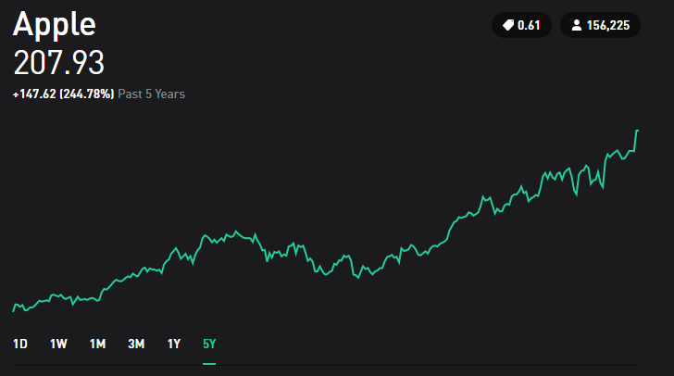

Apple’s Stock 2018

This upward trend, as the name implies is characterized by going “up” and it can be shown with a straight line going up as well. This trend tells us how well the company is doing, and how “Steep” the trend is, can tell us how efficient the company is compared to others. Now we will show 2 stocks that offer upward trends and a “linear approximation” (a single line that tries to follow the pattern of the stock) in blue to see how steep each one of them is.

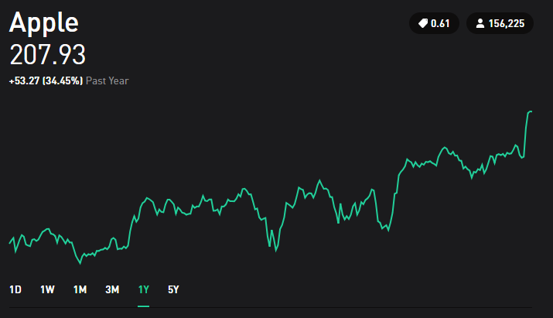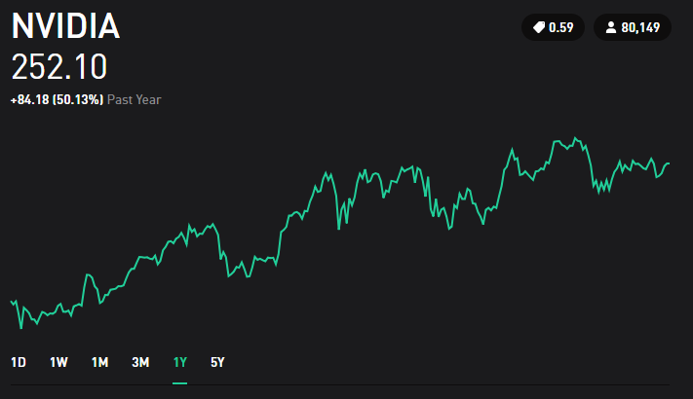

Comparison in between NVIDIA and Apples Stocks

Both show a linear increase, but it can be noticed that the linear approximation (in blue) for NVIDIA is steeper than Apple’s. Therefore, it would be determined that NVIDIA has shown more growth in their stock value. This can also be reinforced by looking at the percentage increases in both. Apple has 34.45% and NVIDIA has 50.13%. Even though this analysis seems simple, you can run through other platforms where information shows too many trends that can be really confusing for the early investors. To show how complicated this can get, let us see an example from Yahoo Finance that has some indicators

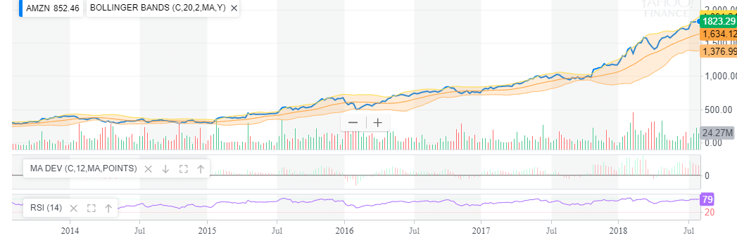

Amazon’s Stock from Yahoo Finance

This type of images should not discourage the early investors. This types of charts offers many “charting tools” that again are trying to be used to predict the future but most likely fail. When in doubt, always go back to the basics of identifying upwards trends. The key points to consider when looking at upwards trends are as follows:

* If you are comparing stocks, make sure they are being compared at the same length of time. Just as NVIDIA and Apple were compared earlier with 1 year of stock history, you need to always compare stocks with the same time of previous stock history. If you compare Apple’s history from last month to Microsoft’s history from last year to decide which one is better, you are not doing it right.
* When analyzing, make sure you are not being disappointed by daily changes. For this, we will take Spotify as an example.

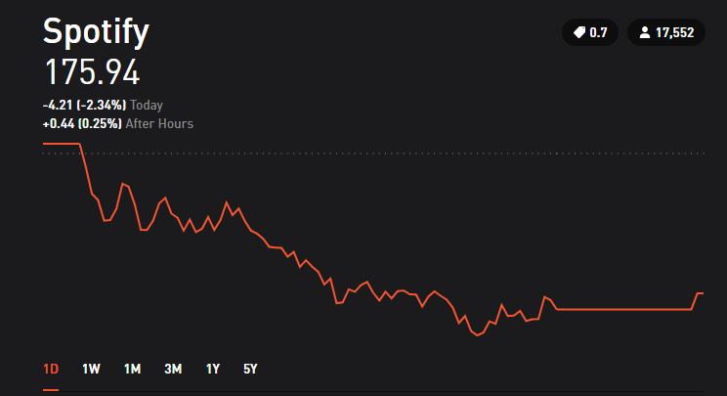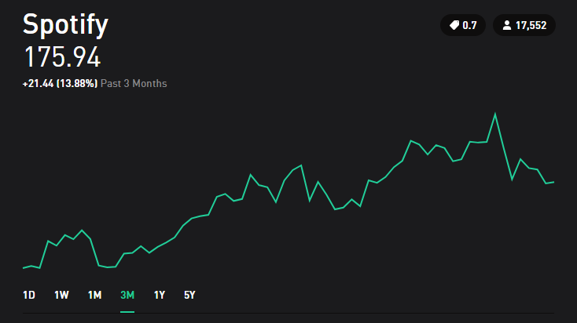

Spotify 1 Day vs 3 Month Trading history

If we look at Spotify’s trend for one day, it is obvious that the loss was considerably bad. However, if we look at the 3-month stock history, we notice how the stock in reality has generated 13.88% increase in price. So always remember that even if the company has had a bad day, does not mean that is doing bad. Now, most of early investors get disappointed by buying stocks and then in one day or week start getting loses and decide to sell the stock before losing more money. However, if they start looking at the long-term information they can deduct that the company has a high chance of giving return on the longer-term investments. **The longer the company has had their upward trend, the higher the chance that the company will keep giving you money on the long-term.**

* The reason why many investors don’t follow these ideas and start selling as soon as they see negative trends is because they want fast money. The reality is that even though is possible to make fast money on the stock market, it is unlikely and hard to achieve. So, the strategies and layouts on this guide serve for long-term investments.
* One safe baseline is to define upwards trends by **at least 1 year** of previous stock history. However, if the company does not have that much time in the market, more research might be needed given that it can be risky to invest in something rather new.

## Downward Trends or “Bearish” Trends

**These trends are the ones you need to avoid at all costs.** The reason to avoid these stocks is simply because they are going down. Some examples for downward trends are the following:

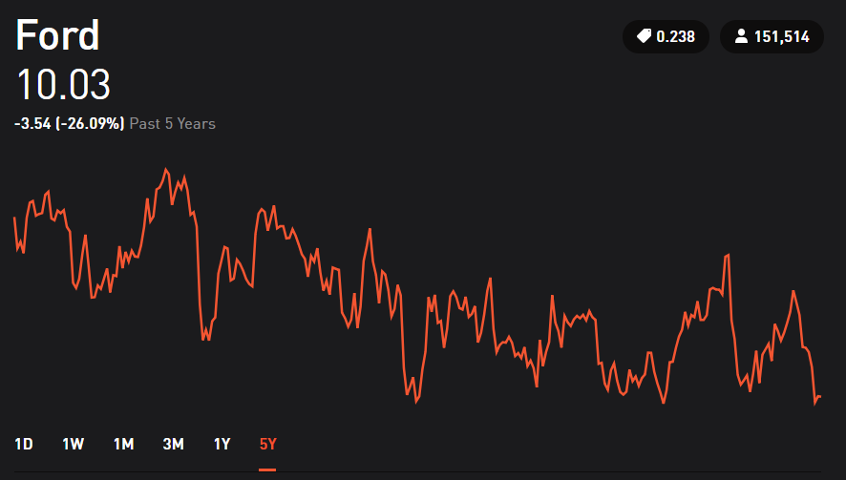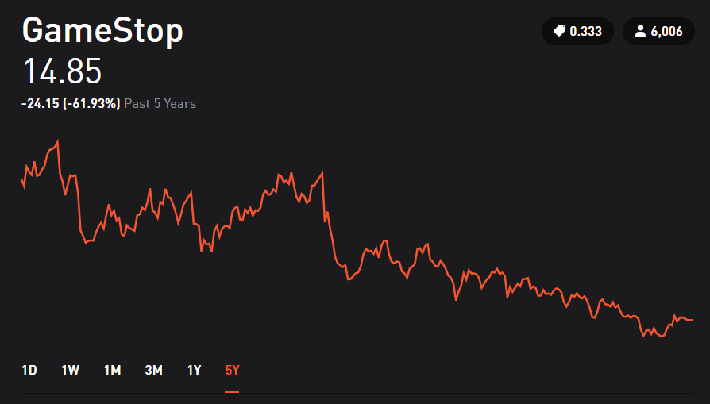

Downward Trend Examples

Some people argue that a downward trend is a sign that indicates that they will go up later. So, they buy the stock when price is decreasing, trying to find the exact time when it will start going up again. Some others argue that if the price once had a certain value, it must go back to that value eventually. **However, from personal research and experience, most (if not all) sources recommend avoiding this type of buying.** The reason behind it, is that there is too much risk involved in the company. Instead of trying to make money, people are focusing on just recovering back they had from that same stock. This can be dangerous because it can bring obstinance in their behavior and start believing price changes that could never happen.

This obstinate behavior is true for either long-term or short-term investments. An example is given for 22nd Century Group.

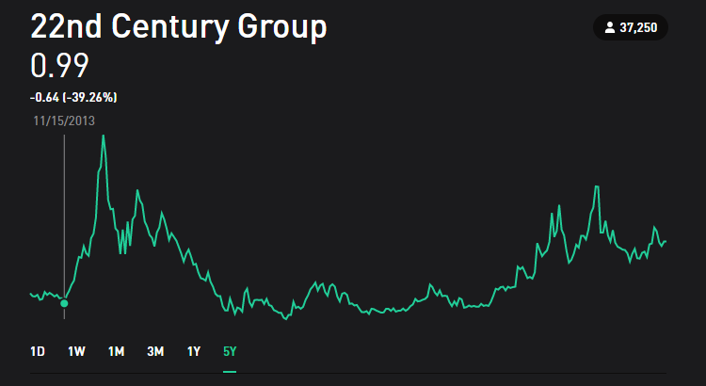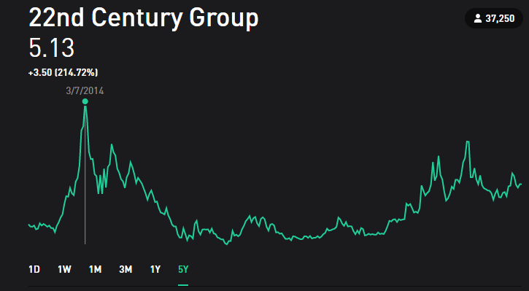

22nd Century Group in 2013 and 2014

If you bought stock in 2013, the value of it was about 1 dollar. After 4 months in 2014, the value of the stock grew 5 times of what it originally was. During this period of time, buying would be recommended. Excitement is high, and returns are good. Now let us look 4 months later, and 3 years later.

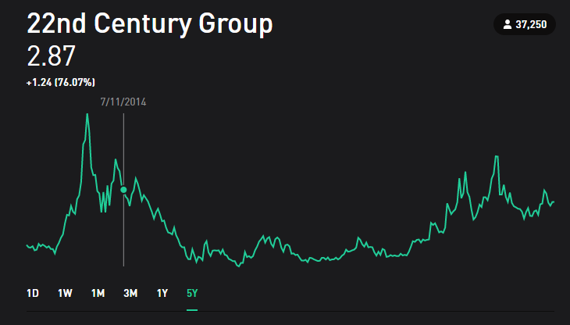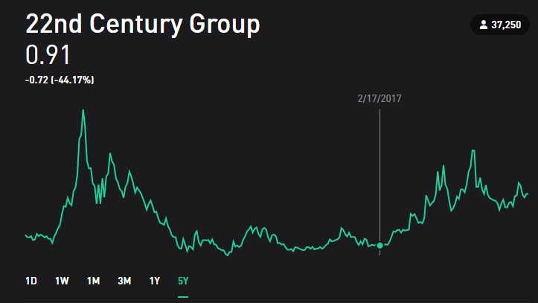

22nd Century Group in 2014 and 2017

Some investors way before this point of time would already have sold their stocks and kept their return instead of holding it longer waiting for more return. **But some investors could be on the idea that the price must go back to 5 dollars, even though they are on a downwards trend, decide to even buy more. That is not a wise move.** Three years later, the stock is valued even less than it was back in 2013. Looking at the history at 5 years, we can see how many investors won a lot of money and then some others lost a lot as well. This behavior of going down and then back up is possible, but is risky, that is why is not recommended for long-term investments.

How could you have avoided this emotional roller coaster? Simply by looking at the long-term performance of the stock. The company back in 2013 did not have a long history of performance, and that short performance was negative. With that in mind, the company **would not** have been an option for investment since the beginning. There could be the claim that the spike that occurred in 2014 would be lost, and that is true. But remember, you are not playing lottery, you are making an investment.

**Remember, investments need to be taken from a logical perspective rather than an emotional one.** Whether you are disappointed with loses, whether you are very excited with profits, it is always recommended to be calm and anticipate how things can change. Now, with all these in mind I invite you to the mindset section.

Some Warnings

For much as I don’t support short-term strategies, it is important to know they exists. When you research for information about stocks, you will find words and definitions that are common among investors who use these “trading techniques”. Often coming from charting ideas, investors make claims about the future performance of many companies. Some examples include:

**Day Trading:** Focuses on finding upwards trends in short amounts of time (hours) and then buy when the price is predicted to keep going up. Then sell when the value of the stock is starting to decrease. The method is risky because requires constantly trading to generate profits.

**Swing Trading:** This trading strategy is like Day Trading but the amount of time for holding a stock is longer (usually days to weeks). This method involves the same idea of buying when the prices is predicted to keep going up for a couple of days and then sell when the value starts to decrease. This strategy is less risky than day trading but still riskier than traditional long-term investments.

**Trend Trading:** Very similar to Reversal Trading, but instead of going “up, down and then up”, the behavior can be quite different. The idea is to find a repeated pattern, could be a mixture of many ups and downs. After identifying this pattern, the objective is to buy the point of the pattern with the cheapest price and sell at the point with the highest price

**Momentum Trading:** Usually investors always seek to “buy low and sell high”. Momentum Trading instead focuses on trends that are “buying high and sell higher”. The time for this strategy can vary from hours to days. The longer a stock is hold, the longer the risk is.

**Reversal Trading:** Reversal means that the stock price is going up, then it goes down, and then will go up again. Investors that look for this pattern concentrate on finding the cheapest price before it goes back up. This technique again serves from hours to weeks. Similarly, to other strategies, the longer the stock is hold, the higher the risk it entails.

Remember that if you want to use any of these strategies, you need to research in detail for the one you want to focus. This was just an overview of some (but not all) strategies. Some people come up with their own trading style that is different from what exists. When it comes to these trading ideas, I often think of “noise”. Which is just something that comes out naturally out of information and is often undesired. For example, sometimes you will hear a beeping sound when you are turning a radio on (happened more often in old radios), or on vinyl record players (you will hear a static sound while the music is playing). All of those are examples of noisy, but what you wanted to hear is the music coming out from those devices. So, stocks have also this “noise” to them which are the small patterns that are presented in the short-term duration, but it is the long term what you should be concerned about. Saying that a spike that occurred during one hour of trading is enough to predict the behavior for 1 year is like saying that the static you hear from the vinyl record told you what the song was all about. To end this little warning, I would like to quote Nate Silver: “Our brains, wired to detect patterns, are always looking for a signal, when instead we should appreciate how noisy the data is”.[3]

The Mindset

If the history of at least 5 years of the company is not a positive trend, it will not be a safe investment. It will be a risky investment with the chance of not making money. **The shorter the time history you are looking at. The higher the risk you are invoking for your decisions.** In essence, that is the only “prediction” I can apply from chart data to my stock making decision. Aside from that, everything else is just an empty promise of profits.

## Smaller Time Frame Trends

Depending on the amount of time history that you are looking, stock price can show different behavior. Taking Exxon for example:

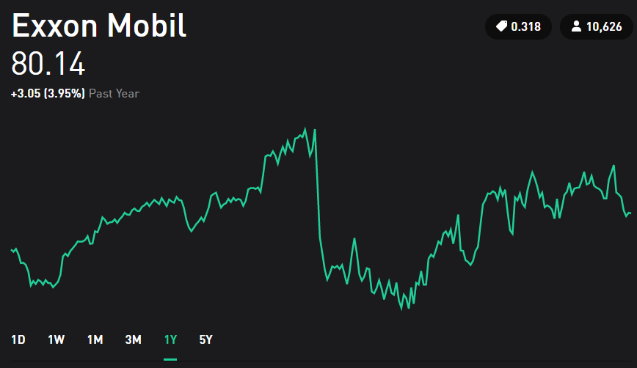

Exxon Mobil – 1 Year History

The behavior instead of being “horizontal”, it seems more like an upward trend, followed by a high decrease, and then another upward trend. If we were to split this graph into 2 sections where one represents 6 months, and the other one 6 months as well, both graphs would have an upward trend. **So many investors decide to break the history of stock prices into smaller sections to predict patterns at smaller time frames. This should be avoided at all times.** Trying to predict smaller time frames is what investment is not about.

Even though many trading strategies are created from the idea of recognizing patterns that will   
“predict” the behavior of the stock, there is simply too many factors that are not taken into account by solely looking at chart movement. Every company has fluctuations in the smaller time frames, and these fluctuations are pretty much unpredictable. Some people might claim to have predicted them, but when asked to predict again, their “methods” will prove to be unsuccessful. There is an incredible amount of information and books that mention people who claim to have a predictive technique and end up failing in the long run [1][2]. Most of these methods include mathematical formulations and terminology for every type of curve movement you can imagine.

But now, think about it in terms of coin tossing, it is possible to predict certain number of outcomes (tails or heads), but after several times you will eventually fail. That same logic applies to the prediction of a small-time frame, some people might get it right sometimes, but not all the time.

Individuals who favor mathematical approaches (as I am one of them) will oppose the idea of now being able to use mathematical formulas for predictions. But we need to grasp that the main problem lies in the data itself. Stock price history does not have enough parameters to make accurate predictions. Furthermore, we have no way of measuring these parameters which bring uncertainty. What do I mean by that? Let us bring an example.

**Fundamental Example #1: Uncertainty, Risk and Measurability**

If you toss a coin, there is a 50/50 chance that you will obtain heads or tails. So, there is a 50% chance of you winning or losing. This “chance” is a measurement of risk.

All good? Let us make it more interesting. Imagine that you are in your friends’ house where you are playing dice. You are given a die and have to guess the number that will appear after throwing it. If we want to measure risk, you will calculate a 1/6 chances or about 16.7% of getting it right. Now it is time to add uncertainty to the table. When you are doing this, you can let your mind turn into a spiral of thoughts. First, imagine that you know the brand of die, and you know from research that this brand is known to produce a smaller dimension in the number 4 face (otherwise known as manufacturing error). If that is the case, the die is not a perfect cube anymore, so it creates a uncertainty. Based on geometry, the die will lean to a specific direction. But you don’t know which one, so you add uncertainty to your calculation. This way your chances of getting it right might be lower to a 15% perhaps. This might not be accurate, but you know as a fact that manufacturing errors change the outcome of the die.

What else could go wrong? What would happen if your friends dog went ahead a eat the die while you were throwing it? Well, it might be paranoid, but if that happens, you would still lose. How would you “calculate” the chances of your friend’s dog munching on your die? Well, this might not seem logical to consider, but it is not impossible for it to happen.

Stocks works similar to that. If you are buying stock for a company, there is a humongous amount of uncertainties. How could you measure the likelihood that the company’s CEO is stealing money from its own company? How about the likelihood of any member in the top position to be imprisoned for any reason you can think of? These questions might sound silly, but they do occur many times. All these silly factors, if they were to occur, would damage the stock value of any company. Does this mean that you should not invest because bad things occur? No. It means that should not believe any of the techniques for predicting stocks in the smaller time trends and should focus on the long-term growth.

## What Affects Trends?

Just because we identify a trend does not mean that it will always stay that way. Sometimes the trends are affected for specific events that many people are not aware of. **It is important to note that a stock’s value reflects how well a company offers services or sell products.** So how their products are sold, how well their services are doing, how the public sees the company and many more factors affect these trends. And now the most important factor in this section: **Not everything about a stock can be predicted by looking only at the graphs.**

**Quick-Example #1 Popularity and Reputation Matter**: If you go to a place where customer service is excellent, the products are really popular and a lot of people you know shop or pay services on this company, then you already have many good signs of how the stock of company should be doing. On the contrary, if the company you are analyzing, has really bad reviews, people don’t ever or stopped going to this company, you can see that this behavior are heavily reflected on the company’s stock. Let us take for product example: Netflix and Blockbuster. Nowadays, everyone has a Netflix account. Most people when talking about movies or series, they refer to Netflix or similar competitors. On the other side, Blockbuster is a company that recently reached bankruptcy. However, for the past 5 years that it was still on the market, nobody would ever mention it, it was uncommon to hear about people going to buy products at Blockbuster.

**Quick-Example #2 Some Businesses are Season-Dependent:** Stocks are representative of a business. So there exists businesses where the time of the year is significant. If you go to a clothing store that focuses on selling winter clothing, then you would not be surprised to see that the earnings of the company and stock prices usually are higher on winter seasons, and then low on summer seasons. Pay attention to the seasons in which businesses work.

The factors that affect trends, are too many to just explain in one chapter. The idea of this chapter was to explain how different trends are identified and how they behave. **The final note on this chapter is to always remember that the time frame that we look at things plays a huge role in our understanding of stocks.** Furthermore, there are other key things to understand before developing a complete strategy in stock trading. These key things are the next chapter.

Based on our beginning chapters, a good investor understands:

* That companies issue stock for sell to sustain their business and grow.
* How Stocks’ charts can only help to select some companies on basis of long-term growth.
* That smaller time frames provide with too many uncertainties to predict them at all.

# Chapter 3: What Affects Stock Prices?

From the previous section, it will be possible to think that there is nothing that can be done to predict the stock behavior because everything is based off random things that we can’t control. However, now we need to address what information can we rely on to understand some stock prices.

The Basics

There exist multiple sources of information that are outside of the stock’s chart that will aid into understanding what affects stock pricing. The first step will be to categorize businesses into different models. Businesses have many target customers and many products or services that they can offer. For this, the following illustration will be used:

Product

Company

Service

Now, you can decide any type of product or service you can think of. In this example, we will have 2 Products and 2 Services as shown below. But remember to investigate many more when you start looking into companies.

Phones

Product

Clothing

Utilities

Company

Service

Restaurants

Warning about Technology companies

The Mindset

# Chapter 5: Stock Trading Strategies

Now that we now all investment types, and we know how stocks behave, we need to understand what to do with those behaviors. This chapter will briefly explain how different trading strategies were first developed, and then give a brief overview on different strategies and how they work. This information will not be enough to do trading on the specific strategy, but to give general knowledge about them to the reader.

## How to Predict Trends?

For starters, **there is no absolute way to predict trends in this world.** Even the most famous and successful investors like Warren Buffet have failed to predict stock prices. Also, every single person is different, and the predictions of everyone will be different as well. For this reason, Stock Trading Strategies were created. These strategies vary depending on many questions such as:

* How fast do you want to make money?
* How much money am I willing to risk?
* How secure do I want my investments to be?
* How much time am I going to dedicate to stock trading?

These questions were pondered by many inventors before coming with different trading strategies. For this guide, we will give a brief explanation on some of the most popular strategies available. We will focus in detail on only a very brief selections of these styles for next chapter.

For the rest of this guide we will focus on one single trading style that can generate secure profits if used wisely. If you want to learn more about other trading styles, Suggested Readings have some recommendations for that.

# Chapter 6: The Suggested Stock Trading Strategy

The first 5 chapters offered the basic knowledge every investor should be aware off and be prepared to consider when making investment moves. From this Chapter on, all the information provided will be referring to how make profits with a stock investment strategy. But first, let us summarize everything we have covered so far.

## Summary of Previous Chapters

Up to now we have covered:

* Different Investment Types
* We focused on Stock Trading Only
* Within Stock Trading there are Basic Trend Classification (Upward, Downward, Horizontal)
* All stocks have those Basic Trend Classifications
* Different Stock Classification Which had two levels: Level 1 (volatility) and Level 2 (product/service)
* Depending on all the stocks categories mentioned before, different trading techniques exist.

It is important to note that up to this point, a beginner should have the essential knowledge to understand what traders do and how stocks can behave. The following image summarizes all this exploring we have gone through and highlights our main objectives which are: Invest in Stocks for Long-Term Trading. Remember that all trend classification and volatility classification work for other forms of investment as well.

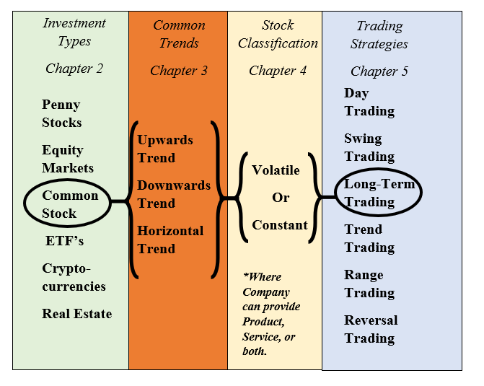

Summary of Previous Chapters on How Investments Work

Now we will **only focus in detail on one** stock trading strategy, rather than explain general ideas of everything that there is out in the world of trading. For the beginner, the next sections will offer you one trading style, but to invest in different investment types or more trading style, it is recommended to explore further into those. Recall the Suggested Readings to learn about other types of trading or investment.

## Long-Term Investments on Stocks

Previously, it was mentioned that the reason for new technology or new companies to be so volatile is because both options of success or failure are somewhat equal. With the idea that you have 50% of making a fortune and 50% of losing everything, **it could be considered gambling.**

Beginner investors fall for the idea that reading some articles on how the performance of a stock will be is enough to make a purchase decision. However, that should not be the case. The more you investigate and develop an understanding about the stock market, your decisions will shift from a gamble to a strategy. The key ideas from this guide to generate profits are as follows (and remember based on experience you can create your own):

* If a Stock has an Upward Trend going for many years, it will probably stay that way on the long-term.
  + The opposite is true for Downward Trend
* Research the company you are investing in. A lot.
  + There will be many examples on Chapter 7 that show how a company can be analyzed that goes beyond from just reading a couple of articles on the stocks.
* Concentrate on Continuous Growth.
  + Even if its small. Growth on the long-term becomes big.
* Diversification is key. More details after this list.
* Do not get impulsive over one day movements. For long-term investments, you should not monitor every hour how your stock is doing
  + This is hard for beginners, but always be patient.
* Avoid Downward Trends
  + Also avoid Horizontal Trends with very little downward behavior.
* Do not invest money you cannot afford to lose.
  + Never use forms of debt (like credit cards) to invest on stocks, first pay your bills.
* Do not believe everything you read from the internet that was written by a person.
  + That is an opinion that could be either true or false.
* Trust more the numbers, and information from the company, that has no personal input.
  + However, be smart on how you interpret those numbers.
* Do not get confident in or attached to stocks.
  + At the end, everything is possible.
* Always be open to learn.
  + The more books you read, the more you can become better at predicting stocks.

Now that we have covered the key points for long-term investments, let us go in detail for some of them.

## Diversification

**Diversification** is a common term in the world of investors, and its meaning is simple. Though, we can elaborate a little bit to understand the importance of have a “Diversified Portfolio”. Usually, when somebody is using diversification it means that you are purchasing stocks from many types of companies. For example, some of your money is in Food Stocks, some other is in Energy Stocks, some other is in Sports Stocks. The idea is that all of them are different **Why? Because, a sector of the market could go down in any moment.** Let us take for example the oil industry. If all your money is invested oil industries, right now there will be income generated, but if you are not careful, in the future there exists the possibility for all oil industries to do bad in the case of an oil-scarce situation. If that is the case, you would lose all your investments in matter of days. If only 10% of all your money is in the oil industry, however, this oil-scarce situation would not make you lose all your investments. This situation seems not likely within the next 10 years or so, but it is just to illustrate the idea.

**Diversification can be considered from a perspective of volatility as well.** We previously saw how stocks can be considered volatile or constant. For long-term investments, it is always recommended to avoid volatile stocks. But if you want to have the chance of skyrocketing your investments, dedicate a safe percentage of your money (usually less than 20% of all your investments) to volatile stocks. That way you have a diverse and safe portfolio that will generate money on the long-term while have a chance to generate big profits for that 20% of risked money. **But always be cautious on where you spend that money. Research on volatile stocks is always harder and trickier to predict.**

**Diversification can consider other investments that are not stocks.** Now that you know many different investment types (such as real estate, cryptocurrencies, and so on), you could consider those as well to be part of your portfolio. This guide will not cover how much percentage of your money should go to each of these investment types because all of them are different and each one of them have more rules to them. However, if you have a portfolio that has 40% invested on real estate and the other 60% on stocks, that would be considered diversification as well.

**Quick-Example #3 Diversify your investments**: This will serve as basic example of a diversified portfolio.

* 15% Volatile Stocks
  + Where this could be technology stocks, or new companies recently arising.
* 65% Constant Stocks
  + Where these focus on continuous growth and upward trends for long-terms
* 20% Other type of Investment
  + Where these could be real estate, ETFs, Index Funds, etc.

Some investors with more experience might consider these percentages as not appropriate and could recommend following a different scheme than this one for either: risking more money or securing more money. So, remember that you need to understand your financial situations to determine how much can you invest and where to invest. Some investors might even recommend avoiding individual stocks at all and focus on Mutual Funds or other forms of investments. But remember, everyone has different approaches and this guide is focusing on Long-Term Stocks Investments.

# Chapter 7: Quick Example List with Strategies

This section has a list of all the Quick-Examples shown in the guide plus some extra examples to illustrate more important points. The final three Chapters 6, 7 and 8 offer a “go-to-section” when you begin your journey on investment. It is recommended to always think on the Suggested Stock Trading Strategy along with the Quick-Examples to make decisions about purchasing stock. The reason for these chapters to be at the end is because these are not “set in stone” principles that will always apply but just “things to keep in mind”. **Nobody will predict the future 100% of the time, but it is up to us to keep our predictions right for more than 60% of the time, and profit will be huge.**

## Quick-Example List

*Previous Examples shown in this guide:*

**Quick-Example #1 Popularity and Reputation Matter: Page 22**

**Quick-Example #2 Some Businesses are Season-Dependent: Page 23**

**Quick-Example #3 Diversify your investments: Page 32**

*New Examples for consideration:*

**Quick-Example #4** **IPOs Create Commotion:** Earlier on Chapter 2, IPO’s were explained as a form to generate capital (money) by putting their stocks on the market. When this happens, many investors tend to get excited about being able to purchase stock for a company that was not available before. The companies that get greatly affected by IPOs are companies that were popular before the IPO. Let us take for example Snapchat. This company’s IPO was in 2017 with a price of about $24. Given that Snapchat had a high popularity back then, it was logical that many investors would see a profitable opportunity in buying this company’s stock. Given that popularity, prices skyrocketed for the Stock going up to about $30 some dollars within just a couple of days. However, after weeks the stock plummeted to less than $20 and people started to panic about it. Finally, it went down to a price below $15 where it currently stands. **Why did this happen?**

This happened because many investors only considered the popularity factor instead of analyzing other circumstances. We need to remember that the amount of money a company has is dependent on two things: How much you owe and how much you make (recall the Basic Accounting Equation from Chapter 2). Because of this, the value of the stock went up **because IPOs created commotion**, and the company received a lot of money from investors. However, for a company to maintain that high increase in value, you need to get money from sales or profits, not only what you owe. We recall that Snapchat is a mobile application for social media that does not have many “money sources”. If we explore Snapchat’s history we see that it has some advertisements on it, but that is about it. Snapchat doesn’t support computers, so accessing websites to make money was not an option. The more we investigate about Snapchat the more we see that it can make profit, but not as much as it seems. For this reason, the price of the stock goes up, and then after a while of not being able to make enough profits, the price will go down. Experienced investors might make the move to buy Snapchat at its IPO value, hold it until it reached a high value of return (about 20%) and **then sell it since they saw that the company would not seem profitable on the long-term.** This type of strategy is valid for long-term investors who see chance of making extra money for buying and selling within two or three days. **Developing this kind of decisions comes from understanding that IPOs create commotion and that you need to learn and understand the company you are buying.**

**Quick-Example #5 Companies are like People offering Business Ideas:** To illustrate this, think about three people. One of them is a total stranger. The other two are your friends, but one of them you know him to be responsible and the other one is not responsible at all. Let’s say that all three of them have the same business idea and they ask you to lend them a lot of money for their idea. **Who would you give the money to?** The answer is simple, but personally I would give my money to my friend that I know is very responsible. Why? Because I know him to be responsible from a long time and I know he will pay me back and give me more if his business is successful. Why would I not lend money to the other two people? Well, I know my other friend well enough to know that he is not going to carry out the business idea properly and I might not get my money back. The stranger actually has both options of being either successful or a failure, but I don’t really know enough information to make a decision from him. Stocks work literally the same way. **The more you know about it, you can tell if it’s a good idea to invest or not. Also, if you don’t know anything about the stock, you need to first learn a lot before even considering investing in that company.**

**Quick-Example #6 Comparing Apples to Apples:** When it comes to investing, some decisions involve in distinguishing in between two similar companies with different stock prices. If both companies offer the same product or service, what makes them different in terms of stock prices? There are different aspects that we have discussed before from Chapter 2. Sometimes companies have small number of shares and that increases the stock prices. Some of them have a lot of shares, so the prices are lower. Now, **if both companies have the same number of shares (but really different prices), what is happening?**

The examples shown in this section are just some out of many examples possible. The more experience you learn, and the more you read, you will be able to make better and more profitable decisions. Remember that it is not possible to predict everything with certainty, but the key is to be intelligent about investments and never let your emotions to carry away your decisions.

# Chapter 8: Key Summary, Pro-Tips and Suggested Readings

This chapter has a summary section for future reference, and some final notes to consider about investing that are not related to the aforementioned strategies.

* Focus on constant growth rather than immediate rewards.
* Investing on Stocks requires knowledge about the company you are investing and understanding many circumstances in which the company might be successful or not.
* Never let your emotions to cloud your thoughts.
* Nobody can predict with 100% certainty the future.
* Do not trust only one article or piece of information. Instead, gather as much information as possible.
* Before trying an investment or a trading style, always research it, and start by paper trading.
* Asses your risks and never invest money that you cannot afford to lose.
* Diversification is key for an investor. The more money sources you have, the higher the likelihood of generating income.
* Historically, the market always goes up. Therefore, long-term investments, if selected correctly, will generate a steady return.

Because they are always useful, here are some **Pro-Tips** that are not directly related to stock trading, but are equally as important to success:

* Learn how to save money, every dollar not spent, is an extra dollar invested.
* Pay all your debt. It doesn’t matter how much money you have saved, or how much money you have invested if you have debt. Debt increases a similar fashion as investments. So, similar on how investments are better on the long-run. Debt is worse on the long-term.
* Always keep in mind: **Becoming financially independent comes from how you save and invest, not how much you make.** Therefore, whatever your financial sitation might be at this very moment, success can always be attained.
* Remember that investing has a certain “emotional” attachment to it that many people don’t recognize. Be smart on your decisions and rationalize them. Don’t let your pride make the decisions for you.
* Keep reading about getting better. The more you know, the more value you can add to your wealth. Don’t be limited to learn only about investments, books about many topics can be helpful to develop new skills or new mentalities that will achieve your goals.

## Notes to consider:

Experienced investors might know that there are **financial ratios** and parameters that are often used into analyzing stocks. Some include: Beta, Price Earnings Ratio, Earnings Per Share, and many more. These are important tools that investors can use to understand stocks. However, **there is no value to calculating or looking at financial ratios if we don’t understand the market from a common-sense point of view first.** Throwing ratios and explaining them might seem like a provision of tools you need and must use. But ratios are tricky without the useful mentality and trend analysis we have described throughout this guide. All trading platforms and many online sources such as Yahoo Finance provide these financial ratios and parameters, but remember that to first understand the numbers, you need to understand where they come from. Which is the key-learning objective of this guide. To create a common-sense mentality of how stocks behave.

If you are a first-time investor, it is important to know that any form of investment must be added to your Tax Return. This guide will not go over any details on taxes, but many early investors might forget or might not know that it is important to consider taxes when you invest.

## Suggested Readings

This section is a list of many sources that are recommended to beginners and remember to keep learning. One key for success in the stock market is to always be open to learning and adapt to changes. Regardless of the strategy you follow, always read, always try, and always learn. Thank you for reading this! Remember, **The Finale for this Guide, is the Beginning of Your Growing Wealth. The Seed has been planted. Now it is Your Turn to Grow it.**

* *Websites on Investing:*
  + Investopedia
  + The Motley Fool
  + Yahoo Finance
* *Books on Investor Mentality:*
  + How to Think like a Millionaire – Frank Fisher
  + The Science of Getting Rich – Wallace D. Wattles
* *Initial Books on Other Trading Strategies:* 
  + The Index Fund Solution – Richard E. Evans
  + Penny Stocks for Dummies – Peter Leeds
  + How to Day Trade for a Living – Andrew Aziz
* *Classics of Investing:*
  + Business Adventures: Twelve Classic Tales from the World of Wall Street – John Brooks
  + The Intelligent Investor: The Definitive Book on Value Investing – Benjamin Graham
  + The Little Book of Common Sense Investing – John. C. Bogle
  + A Random Walk down Wall Street: The Time-tested Strategy for Successful Investing – Burton G. Malkiel